**PATUAKHALI SCIENCE AND TECHNOLOGY UNIVERSITY**

Course Code: C

IT

-

11

2



**SUBMITTED TO:**

Prof. MD Mahbubur Rahman Sir

**Department of Computer Science And Communication**

**Engineering**

**Faculty of Computer Science And Engineering**

**SUBMITTED BY:**

Name: MD Noushad Bhuiyan

ID: 2102038, Registration No: 10165

Faculty of Computer Science and Engineering

**Date of submission: 5-3-2023**

#include<stdio.h>

struct st{

int hour,min,sec;

};

int main()

{

struct st time={16,40,51};

printf("%d:%d:%d",time.hour,time.min,time.sec);

}

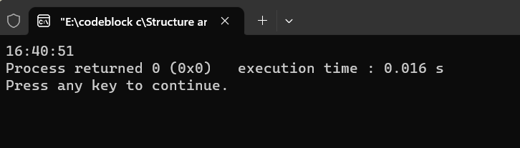



#include<stdio.h>

struct st{

int hour,min,sec;

};

int main()

{

struct st time;

printf("Enter timezone in hour:\n");

scanf("%d",&time.hour);

printf("Enter timezone in minute:\n");

scanf("%d",&time.min);

printf("Enter timezone in second:\n");

scanf("%d",&time.sec);

printf("\n\nThe time is:\n");

printf("%d:%d:%d",time.hour,time.min,time.sec);

}

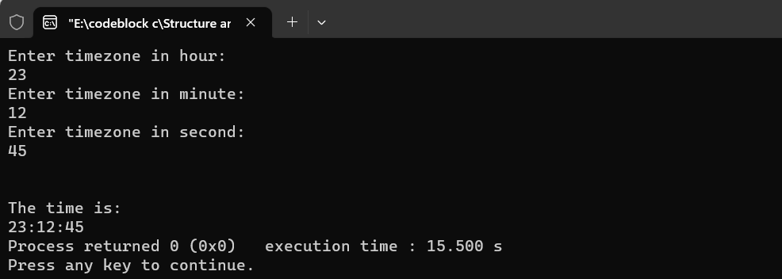



#include<stdio.h>

struct st{

int hour,min,sec;

};

int main()

{

struct st time;

printf("Enter timezone in hour:\n");

scanf("%d",&time.hour);

printf("Enter timezone in minute:\n");

scanf("%d",&time.min);

printf("Enter timezone in second:\n");

scanf("%d",&time.sec);

struc(time.hour,time.min,time.sec);

}

void struc(int a,int b,int c){

int h,m,s;

h=a+1;

m=b+1;

s=c+1;

if(h==24)

h=0;

if(m==60)

{

m=0;

h++;

}

if(s==60)

{

m++;

s=0;

}

printf("\n\nThe time is:\n");

printf("%d:%d:%d",h,m,s);

}

